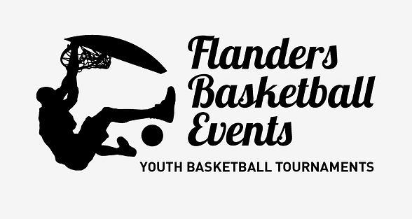

www.flabasevents.com
flabasevents@gmail.com
(0032)(0)473 37 39 66
Belgian Coast Challenge 2025
May 23th/24th
U10/U12/U14 (mixed)
To all team managers and coaches,
It’s with much pleasure that we can invite you to our traditional two days Spring tournament “Coast Challenge” for U10/U12/U14 teams in at the Belgian Coast, this year in De Panne.
During two days your team can enjoy fantastic basketball games, the sea, the beach and the beautiful dunes.
You need to have your own transport.
Every team plays 5 adapted games (3 on Saturday and 2 on Sunday). In the past we had teams from all over Belgium, but also from Holland, France, England and Germany.
We work with tournament passes. Every team needs to buy at least 9 tournament passes. The pass for the coach and 12th. player is for free.
A pass costs 30 euros and comes with :
- an original tournament T-shirt
- A tournament medal
- A nice trophy for the team
- A gift for the coach
The price without T-shirt is 22,50 euros
The results, rankings and competition schedules can be consulted at any time during the tournament on a handy app, so that you can also consult them in your hostel, on the beach or wherever you are.
We also create a digital tournament booklet with a presentation of all teams. If you have a sponsor who is willing to pay for your registration fee and/or accommodation, this sponsor can be included in this booklet with its logo and any further publicity.
Accommodation: accommodation is possible in one of the many hostels in the municipality and in the region. Check out our website on the “our hostels” page for some examples. You can arrange your own accommodation completely, but we are also happy to help you inquire about prices and availability and possibly even take a temporary option until you can make a final decision. Ultimately, you will make the official reservation yourself. If you arrange all your own accommodation yourself, please keep us informed of your results
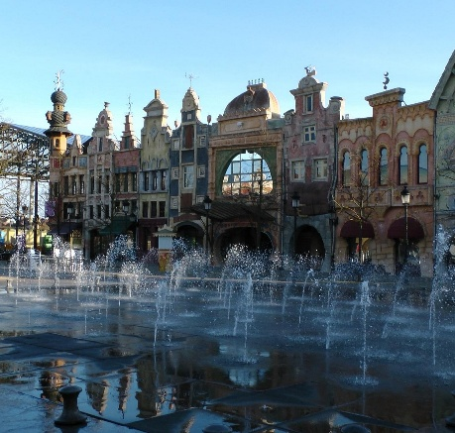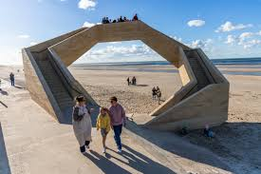
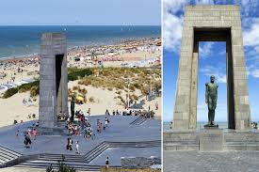

Inscription form Coast Challenge 2026
To : flabasevents@gmail.com

Club : ………………………………………………………………………………………………
Correspondent : ……………………………………………………………………………………………
e-mail : …………………………………………………………………………………………………………
mobile : ……………………………………………………………………………………………………………
Participates with :
O U10
Manager present : ……………………………………………………………………………….
mobile : …………………………………………………………………………………..
O U12
Manager present : ……………………………………………………………………………….
mobile : …………………………………………………………………………………..
O U14
Manager present : ……………………………………………………………………………….
mobile : …………………………………………………………………………………..

