
International Basketball Trophy 2026
Bruges Saturday 11th. and Sunday april 12th.
Tournament for U14/U16 and U18 boys
www.flabasevents.com
flabasevents@gmail.com
(0032)(0)473373966
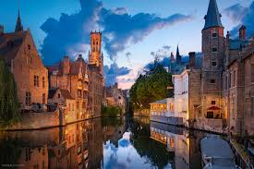
Play exciting matches against teams from Flanders, Wallonia, the Netherlands and possibly from other countries. The matches are played in KTA Brugge within walking distance of the beautiful center of Bruges and the train station.
The competition schedules, results and rankings can be consulted at any time via a handy app. so you can follow it wherever you are.
All teams are presented in advance in a digital tournament booklet that you can distribute to parents and other supporters of the club.
-New ! Earn your registration fee back. If you can convince a self-employed person or company to sponsor your registration fee, we will place this sponsor free of charge in the tournament program booklet and on our website

Participation:
To participate in the tournament, each player must purchase a Players Pass. This Players Pass entitles you to the following:
- an original tournament T-shirt
- a medal
- a nice trophy for the team
This Players Pass costs 27.50 euros per player (20 euros without T-shirt). The 12th pass, on the other hand, is always free. There is also a free Coach Pass for the (head) coach. This entitles you to:
- an original tournament T-shirt (if players pay for T-shirt)
- gift
- a medal
Accommodation and catering
There are many options for teams that require accommodation in the region.
a) You simply arrange everything in advance at the hotel or hostel of your choice. Please let us know where and for which days you have taken accommodation.
b) You ask us to inquire at one of the hostels that we propose below this invitation. We check whether there is room, what the exact prices are, etc. After your approval, we will choose an option for your stay, an option that you will then confirm when you are sure of your participation. You will then handle further processing of reservations and payments yourself. Since it is the Easter holidays, some hostels may fill up quickly in this tourist region. So don't wait too long.
If you would like certain meals during the tournament, please let us know. We can possibly have meals delivered to our sports complex through a caterer or we can recommend certain restaurants and possibly make reservations according to your wishes.

Please be aware of possible cancellation costs with every effective reservation. There is always a very small possibility that the tournament cannot take place due to circumstances beyond our responsibility. In that case, we as an organization are of course not responsible for the cancellation costs incurred by you.

Region
The Bruges region is ideal for spending a few days on holiday, combined with a fun tournament. The historic city of Bruges itself, within walking distance of our room, is a UNESCO world heritage site and is visited daily by thousands of tourists from all over the world. You will find the beaches of our Belgian coast less than 20 km away. Places such as Knokke-Heist, Blankenberge and Ostend are well known to coastal enthusiasts. Nearby you will also find the Zwin region, with some nice, small historic towns such as Damme and Sluis (NL) that are definitely worth a visit. Large bustling Belgian cities such as Ghent, Antwerp and Brussels are a little further away, but are possible temporary stopping places when traveling to or from the tournament.

Registration International Basketball Trophy April 11th. and 12th., 2026
Club : ………………………………………………………………………………………..
Contact : …………………………………………………………………………….
e-mail address : ………………………………………………………………………………….
Telephone : ……………………………………………………………………………………..
Participates with:
O U14 mixed
Person responsible on site + mobile: …………………………………………………………………..
O U16 boys
Person responsible on site + mobile: …………………………………………………………………..
O U18 boys
Person responsible on site + mobile: …………………………………………………………………..

Proposed hostels
De Loyale Maldegem
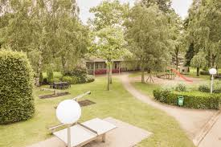 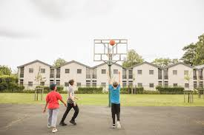
https://www.jeugdherbergen.be/nl/maldegem
Herdersbrug Dudzele
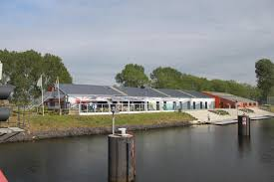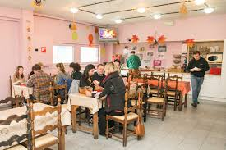
https://www.jeugdherbergen.be/en/brugge-dudzele

Europa Brugge
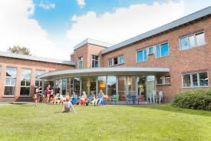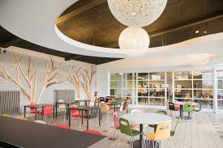
https://www.jeugdherbergen.be/nl/brugge
De Ploate Oostende (kust)
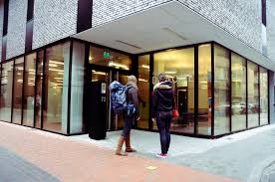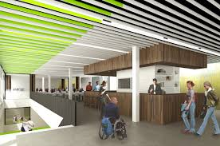
https://www.jeugdherbergen.be/nl/oostende
Lakeside Paradise Knokke-Heist (kust)
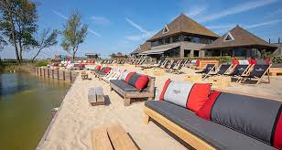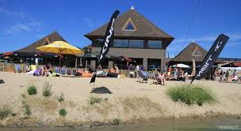
https://www.lakesideparadise.be/
Ibis Budget Brugge Station
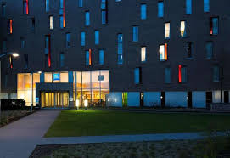
https://all.accor.com/hotel/5046/index.en.shtml

