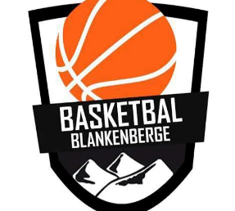
Flanders Classic Cup 2024
Blankenberge 24 and 25 august
Tournament for U14 mixte, U16/U18/ boys and U14/U16/U19 girls
www.flabasevents.com
flabasevents@gmail.com
(0032)(0)473373966
Yes, we are back with the Flanders Classic Cup. And how? From this year onwards in Blankenberge on the Belgian coast in the brand new sports hall with 4 courts, located just 500 meters from the beach. This tournament is therefore the ideal preparation for the new season for most youth categories and of course also a fantastic team building for your team. Play matches against teams from Flanders, Wallonia, the Netherlands and possibly from other countries.
In addition to the regular tournament on Saturday evening, we normally also provide a great All-Star Game for most categories, where the best players compete against each other. A digital tournament booklet is also created in advance with a presentation of all teams. Finally, competition results, rankings and subsequent rounds will be continuously visible on a handy app. which can be consulted anywhere, so that you always stay informed of the state of affairs, whether in your accommodation, on the beach or anywhere during outings.
Participation:
To participate in the tournament, each player must purchase a Players Pass. This Players Pass entitles you to the following:
- an original tournament T-shirt
- a medal
- a nice trophy for the team
This Players Pass costs 27,50 euros per player including T-shirt or 20 euros without T-shirt. The 12th pass, on the other hand, is always free. There is also a free Coach Pass for the (head) coach. This entitles you to:
- an original tournament T-shirt (if players pay for T-shirt)
- original gadget
- a medal
-New ! Earn your registration fee back. If you can convince a self-employed person or company to sponsor your registration fee, we will place this sponsor free of charge in the tournament program booklet and on our website.
Accommodation and catering
There are many options for teams that require accommodation in the region.
a) You simply arrange everything in advance at the hotel or hostel of your choice. Please let us know where and for which days you have taken accommodation.
b) You ask us to inquire at one of the hostels we propose below this invitation (or others). We check whether there is room, what the exact prices are, etc. After your approval, we will choose an option for your stay, an option that you will then confirm when you are sure of your participation. You will then handle further processing of reservations and payments yourself. Since it is still the summer holidays, certain hostels may fill up quickly in this tourist region. So don't wait too long.
If you would like certain meals during the tournament, please let us know. We can possibly have meals delivered to our sports complex through a caterer or we can recommend certain restaurants and possibly make reservations according to your wishes.

Please be aware of possible cancellation costs with every effective reservation. There is always a very small possibility that the tournament cannot take place due to circumstances beyond our responsibility (e.g. too few registrations for a certain category, etc.). In that case, we as an organization are of course not responsible for the cancellation costs you incur.

Region
Blankenberge is probably the most vibrant seaside resort on the Belgian coast. On Sunday, August 25, during the tournament, the annual flower parade will also take place, which will attract a lot of people. Trips are of course possible to other famous places on the coast such as Ostend or Knokke-Heist or to the beautiful historic city of Bruges.

Registration Flanders Classic Cup Blankenberge August 24/25, 2024
Club : ………………………………………………………………………………………..
Contact : …………………………………………………………………………….
e-mail address : ………………………………………………………………………………….
Telephone : ……………………………………………………………………………………..
Participates with:
O U14 mixed
Person responsible on site + mobile: …………………………………………………………………..
O U16 boys
Person responsible on site + mobile: …………………………………………………………………..

O U18 boys
Person responsible on site + mobile: …………………………………………………………………..
O U14 girls
Person responsible on site + mobile: …………………………………………………………………..
O U16 girls
Person responsible on site + mobile: …………………………………………………………………..

O U19 girls
Person responsible on site + mobile: …………………………………………………………………..

Suggested hostels
De Loyale Maldegem
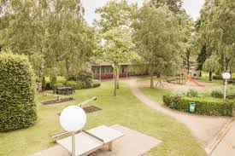 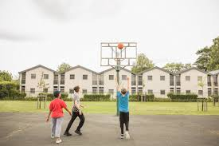
Alle info : https://www.jeugdherbergen.be/nl/maldegem
Herdersbrug Dudzele
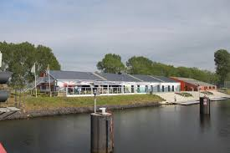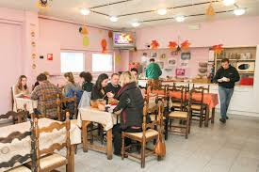
Alle info : https://www.jeugdherbergen.be/en/brugge-dudzele

Europa Brugge
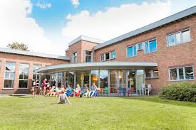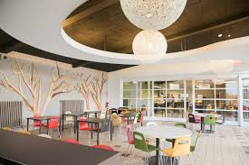
Alle info : https://www.jeugdherbergen.be/nl/brugge
De Ploate Oostende (kust)
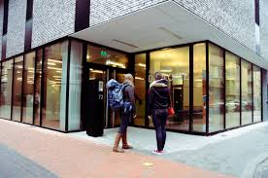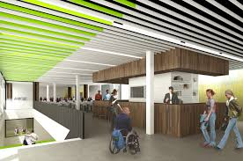
Alle info : https://www.jeugdherbergen.be/nl/oostende
Lakeside Paradise Knokke-Heist (kust)
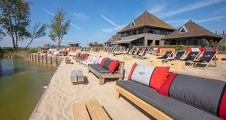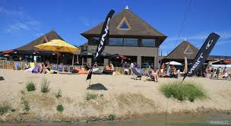
Alle info : https://www.lakesideparadise.be/
Ibis Budget Brugge Station
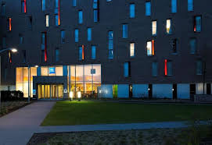
Alle info : https://all.accor.com/hotel/5046/index.en.shtml
