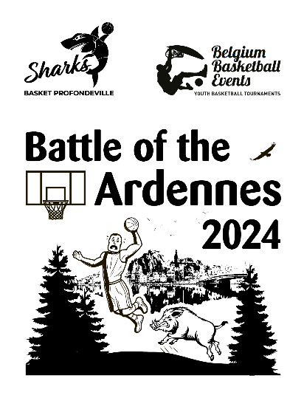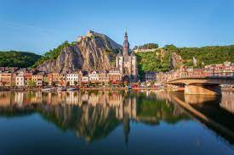
www.flabasevents.com
flabasevents@gmail.com
0473 37 39 66
Battle of the Ardennes 2024
25th.and 26th of may
U10/U12/U14 (mixte)
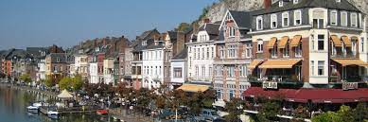
Dear coach or team manager,

It is with great pleasure that we can invite you to our brand new two-day spring tournament for U10/U12 and U14 teams in Profondeville in the heart of the Ardennes (between Namur and Dinant, beautifully situated on the Meuse). It will without a doubt be the most fun and enjoyable tournament you can imagine.
For two days you can enjoy exciting basketball matches and the beautiful region.
Matches are played in the municipality's sports hall (3 fields). Accommodation and dinner on Friday and/or Saturday evenings is possible in one of the accommodations in the region (see below).
Own transport is necessary.
Each team plays 5 modified matches (normally 3 on Saturday and 2 on Sunday). In any case, we hope for participants from the region, but also from Flanders and abroad.
We work with so-called tournament passes. Each participating team must always purchase at least 9 passes (for foreign teams who decide fast, we have special offers, so please contact us for information). The pass is always free for the 12th player and the coach. A tournament pass costs 20 euros (possibly 12.50 euros without T-shirt) and includes:
- participation in the tournament
- an original tournament T-shirt
- a medal
- a nice trophy for the team
- a practical basketball gift for the coach

On Saturday evening we provide an All Star Game for the U12 and U14 categories, in which a team of the best Belgian players competes against a team of the best foreign players.
The results, rankings and competition schedules can be consulted at any time during the tournament on a handy app, so that you can also consult them where ever you are.
We also create a digital tournament booklet with a presentation of all teams. If you have a sponsor who is willing to pay for your registration fee and/or accommodation, this sponsor can be included in this booklet with its logo and any further publicity.

Accommodation: accommodation is possible in one of the hostels, hotels or gites in the municipality and in the region. Check out our website on the “our hostels” page for some examples. You can arrange your own accommodation completely, but we are also happy to help you inquire about prices and availability and possibly even take a temporary option until you can make a final decision. Ultimately, you will make the official reservation yourself. If you arrange all your own accommodation yourself, please keep us informed of your results.
Meals: hot meals are usually available in the hostel where you are staying. On request we can also have hot meals delivered to the sports hall.

Registration form Battle of the Ardennes 2024
To : flabasevents@gmail.com

Club : ………………………………………………………………………………………………
Correspondent : ……………………………………………………………………………………………
e-mail : …………………………………………………………………………………………………………
mobile : ……………………………………………………………………………………………………………
enters tournament with :
O U10
Number of players (latest april 15th.) : ………….
manager present : ……………………………………………………………………………….
mobile : …………………………………………………………………………………..
O U12
Number of players (latest april 15th.) : ………….
manager present : ……………………………………………………………………………….
mobile : …………………………………………………………………………………..
O U14
Number of players (latest april 15th.) : ………….
manager present : ……………………………………………………………………………….
mobile : …………………………………………………………………………………..

