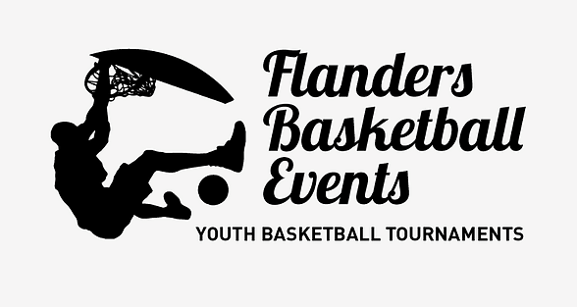

[***www.flabasevents.com***](http://www.flabasevents.com)[***flabasevents@gmail.com***](mailto:flabasevents@gmail.com) ***0473 37 39 66***

***Dunes de Flandre U10 Cup 2025  
august 30th. 2025***

Dear coach or team manager,

In preparation for the new season, would you like to play a tournament abroad and at sea with your U10 team. It is possible with our tournament. It takes place in Bray-Dunes, on the northern French coast, just across the border past De Panne. We have room for a maximum of 5 non-French teams. So register quickly is the message.

The cost is 17.50 euros per player (minimum 8 players), the 12th player is free.

- participation in the tournament

- an original tournament T-shirt

- a medal

- a nice trophy for the team

- a practical basketball gift for the coach

Participation without a T-shirt is also possible. Then the cost is 10 euros per player.

The results, rankings and competition schedules can be consulted at any time during the tournament on a handy app, so that you can also consult them in your hostel, on the beach or wherever you are.

We also create a digital tournament booklet with a presentation of all teams. If you have a sponsor who is willing to pay for your registration fee and/or accommodation, this sponsor can be included in this booklet with its logo and any further publicity.

**Registration form Dunes de Flandre U10 Cup**

Envoyer à [flabasevents@gmail.com](mailto:flabasevents@gmail.com)

Club : ………………………………………………………………………………………………

Correspondent : ……………………………………………………………………………………………

e-mail : …………………………………………………………………………………………………………

mobile : ……………………………………………………………………………………………………………

O U10  
number of plauers, the latest august 15th.) : ………..  
Responsable person at the tournament : ……………………………………………………………………………….  
mobile : …………………………………………………………………………………..