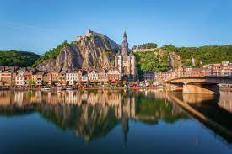
www.flabasevents.com
flabasevents@gmail.com
0473 37 39 66
Battle of the Ardennes 2026
May 16th and 17th
U10/U12/U14 (boys and girls allowed) and U16 boys
.
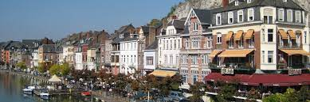
Dear coach or team manager,

We are pleased to invite you to the third edition of our two-day spring tournament for the U10/U12, U14 and boys U16 teams in Profondeville in the heart of the Ardennes (between Namur and Dinant, beautifully situated on the Meuse). This will undoubtedly be the most fun and enjoyable tournament you can imagine.
For two days you can enjoy exciting basketball matches and the beautiful region.
The matches will be played in the sports hall of the municipality (3 courts). Overnight stays and meals on Friday and/or Saturday evenings are possible in one of the accommodations in the region.
Own transport is necessary.
Each team plays 5 adapted matches (normally 3 on Saturday and 2 on Sunday). In any case, we hope for participants from the region, but also from Flanders and abroad.
We work with so-called tournament passes. Each participating team must always purchase at least 9 passes. The pass is always free for the 12th player and the coach. A tournament pass costs 25 euros (possibly 17.50 euros without a T-shirt) and includes:
- participation in the tournament
- an original tournament T-shirt
- a medal
- a beautiful trophy for the team
- a gift for the coach
Results, rankings and match schedules can be viewed at any time during the tournament on a handy app, so that you can view them wherever you are.
We also make a digital tournament booklet with a presentation of all teams. If you have a sponsor who is willing to pay your registration and/or accommodation costs, that sponsor can be included in this booklet with his logo and other advertising.

Accommodation: is possible in one of the hostels, hotels or gites in the city and region. You can arrange your accommodation yourself, but we are also happy to help you with information about prices and availability and, if necessary, even take a temporary option until you can make a final decision. Ultimately, you make the official reservation yourself. If you arrange your own accommodation, please keep us informed of your results. We can normally also provide a lot of sleeping places at democratic prices in the boarding house of a school.
Meals: Hot meals are usually available in the hostel where you are staying. During the tournament, various (hot) snacks will also be available in the vicinity of the hall.

Registration Battle of the Ardennes 2026
Op te sturen aan flabasevents@gmail.com

Club : ………………………………………………………………………………………………
Correspondent : ……………………………………………………………………………………………
e-mail : …………………………………………………………………………………………………………
mobile : ……………………………………………………………………………………………………………

O U10
Responsible person at the tournament : …………………………………………………………………….
Mobile : …………………………………………………………………………………..
O U12
Responsible person at the tournament : …………………………………………………………………….
Mobile : …………………………………………………………………………………..
O U14
Responsible person at the tournament : …………………………………………………………………….
Mobile : …………………………………………………………………………………..
O U16 boys
Responsible person at the tournament : …………………………………………………………………….
Mobile : …………………………………………………………………………………..

